Ronney Aovida

1/29/17

Practicum/Thesis

Stock Trading Strategies Back Test- Proposal

**Introduction/Importance:**

Currently The United States is a Capitalistic society, where its trade and industry are controlled by private owners/companies. It is because of this system that the stock exchange has become a large distribution of wealth between individuals and companies. This distribution of wealth is done through individuals purchasing securities/shares (a claim on the company’s assets and earnings) of a company that decides to go public. When a company goes public it becomes a publicly traded and owned entity, meaning that the company's success is now also the success of its shareholders. A stock's price is usually determined by simple supply and demand of its investors (shareholders) and based on what investors believe the company is worth based off its Earnings Report [Folger,2015]. However there is currently no known method of predicting exactly how much a company’s stock is actually worth in real time since the price of a stock is almost always either rising or falling due to investors either selling or buying at all times (it is possible to purchase stocks even after the market is closed). The reason for its unpredictability is the same reason no outcome using human decision making is 100% accurate, because human beings themselves are unpredictable [Cziko,1989]. Now that it is established that it is currently not possible to predict a human's decision making process 100% accurately, we will strive to instead attempt to predict it with a lower but effective amount of accuracy using past data. By looking into the history of a stock's prices rise and fall, we can attempt to find patterns that occur during certain time frames. These patterns are found typically by using Technical Indicators, which do not analyze any part of the fundamental business  such as earnings, revenue or profit margin, but rather analyzes prominent trends using different techniques that incorporate the stocks past prices and/or volume [Blume,1994]. It is using these indicators that this project is based upon for testing trading strategies. These indicators will indicate when a stock should be bought or sold based on different approaches, some of which will be more successful with some stock and others not so much. These strategies will be designated towards day trading and swing trading rather than long term investing since finding patterns for the long term is a much more vigorous task that is not very accurate at most times. It is my hope to coordinate which trading strategies are the most optimal in relation to a stocks industry and volatility.

**Previous work/Background:**

The reasoning for this project stems from two intuitive reasons, to test if a trading strategy is capable of being a second confirmation signal for trade investments assuming fundamental analysis is not accurate enough, and to confirm that current strategies

will result in profitability in relation to short term investments. In Hang, Zhou and Zhu’s paper (cited in references) that consists of over 30 other scholarly cited papers, they go on to explain how technical analysis is a methodology for forecasting the direction of security prices through the study of past market data and how it is currently widely used by many practitioners. They prove this through a survey of 692 fund managers that reported 87% of them placing some importance on technical analysis when making their investment decisions. In Han, Yang and Zhou in their paper (cited in references) that is written in relation to over 50 scholarly cited sources, they explain how their research is conducted using the technical tool of Moving Averages to time investments. This is a Trend-following strategy and hence the profitability of the strategy relies on whether there are detectable trends in the cross section of the stock market. Their results for the Moving Average timing strategy was applied to the Center for Research in Security Prices volatility docile portfolios by computing a 10-day average price of it. They compared their results to the buy-and-hold strategy and found that the MA returns were positive and were increasing with the volatility docile, where as the buy-and-hold strategy did not perform as well.

Knowing the reasoning behind the project leads to the discussion of what a trading strategy is and how they are formed. Jean Folger a technical analyst and system researcher who is an affiliate of the Market Technician Association explains in her article “indicators and strategies explained” (see references), that technical trade strategies employ technical indicators in an objective manner in order to determine entry, exit and/or trade management rules. It is a definitive set of rules that specifies the exact conditions under which trades will be established ,managed and closed. As was stated before, an indicator is not a trading strategy, but rather they help traders identify market conditions; a strategy is a traders rulebook: How the indicators are interpreted and applied in order to make educated guesses about future market activity [Folger,2016]. A few categories of technical trading tools include Trend, Volume, Volatility and Momentum indicators. A solid strategy is typically made up of multiple indicators using different variables rather than the same ones, otherwise known as multicollinearity, of which should be avoided since it will do nothing but return redundant results. In Folgers article she provides a table providing examples of types of technical indicators, as seen in Figure 1 below.

Figure 1:

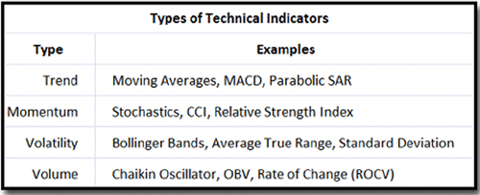

In this Project, the goal is to find trading strategies that implement these indicators and back test them with past stock market data in different sectors of industry and volatility levels, in hopes of finding which strategies will be the most optimal in each situation.

**Proposed work/Expectations  :**

The work I will be doing is back testing some trading strategies using python. These strategies will be using Technical Indicators together in order to find and hopefully predict a stock's future price somewhat accurately. In order to do this I will need to first collect years of past stock data from approximately 50-100 different stocks and import their data into the program. The stocks selected will then be organized into subcategories of volatility and industry. Trading strategies then need to be determined, dictated by the type of indicators they use [Woods,2017]. There are many potential trade strategies developed by many researchers [Woods, 2017], but of course not all of them are the most optimal with any stock. A few examples of these strategies are shown in the Tables/Graphs page below. These strategies will be implemented by me using python and then back tested on the data gathered. These back tests however take in one crucial variable, time frames, these will need to be used to determine what time period I will be applying the strategy indicators to. A time frame is usually determined by what size trend is being analyzed, they can be classified as primary, intermediate or short term. However markets do tend to exist in several time frames simultaneously [Fundora,2016]. As such, there can be conflicting trends within a particular stock depending on the time frame being considered. It is not out of the norm for a stock to be in a primary uptrend while being mired in intermediate and short term down trends. Depending on what type of trading will be conducted, such as swing trading or day trading, will determine what type of time frame will be used. An example of this would be, as a swing trader: a weekly chart will be used to define a primary trend while a 60 minute chart can be used to define the short term trends. In this project we will be exploring both swing and day trading, so time frames will vary depending on which type of trade is happening [Fundora,2016]. With a trade strategy and time frame selected, I will be able to back test the data and compare them between which ones work best in which industry/volatility and if best used for swing/day trading.

I expect the results to be more accurate in certain groups of stocks, particularly the industry related group, based off of a observation taken over a few months where if one or two stocks are falling, there tends to be more stocks in the same industry falling at the very same time. Another expectation I have for this project is a accurate showing of how psychology plays a part in highly volatile stock. Highly volatile stocks are harder to predict because of their volatility, and I believe this is due to a financial psychology factor being in play. According to a scholarly paper written by Soosung in 2003, elaborates on herding in the stock market. This is the mentality characterized by a lack of individual decision-making or thoughtfulness, causing people to think and act the same way as the majority of those around them [Soosung, 2003]. This meaning that when a volatile stock starts to rise or fall, it rises or falls hard and fast due to everyone either joining in the bullish rise or departing from the bearish fall. I argue that with technical analysis, I should be able to find these patterns in these volatile stocks that prove that even a small rise or fall in a stock can indicate a larger outcome than expected, before knowing it will happen.

**Milestones:**

2/06/2017:   I plan to have a complete understanding of the project overall. I will have collected all the stock data for the project and analyze all available Technical indicator trading strategies I can find.

2/25/2017:  I will have all data sorted into groups, graphed out with some simple Technical overlays for analysis of trends. I will have identified some Trends and start experimenting on some trading strategies that I find to be the most promising.

4/1/2017:  I will have organized each set of stock data into its own groups and have them graphed out. Trends will have been found for each subcategory of stocks along with nearly optimal time frames for each trading strategy implemented so far. I will have successfully back tested at least one trading strategy with a good amount of accuracy, and documented the differences between each stock in its respective category and the difference between the stock categories (categories being volatility and industry).

4/22/2017:  All stock data has been back tested with at least 3 different trading strategies that return a good amount of accuracy with sub optimal time frames. I will have documented whether each strategy is best used as a day trade or swing trade, and if it is best suited for volatile stocks, stocks of industry or neither. Conclusions and Results will be drawn up.

4/27/2017:  All work will be thoroughly reviewed and documented for accuracy. The results should return with at least 3 trading strategies that return a good amount of profit in either the highly volatile group or Industry group. A section mentioning which trading method (day trade or swing trade) returned higher amounts of profit, along with the pros and cons of each method under these circumstances.

**Summary:**

This project is in relation to Stock analysis and finding trading strategies that are capable of finding patterns from stocks of high volatility and industry, in order to find an more optimal method of predicting future stock prices. This will be done by collecting past data from 50-100 different stocks and organizing them into their respective volatility or industry categories. Technical overlays will then be implemented in order to find what trends should be analyzed. With a Trend found, a trade strategy that best suits the trend, momentum, volatility and volume of the stock will be back tested on it. When back testing however, a good time frame makes a huge difference in the results, so many different time frames will be tested in order to determine if this strategy is best as a day trade or swing trading strategy, in relation to that certain stock. Whatever trading strategies come out with the best return/profit from a single stock will then be compared to other stocks of the same category as the original in order to determine if the strategy is truly accurate. If the strategy being tested is not compatible with stocks in the same category as the originally tested one, then the differences between the two will be noted and another strategy will be determined based off of how it can satisfy the differences the other strategy previously could not.

**Tables/Graphs:** Below are a few examples of Trading strategies for reference and understanding. Citation: [Woods,2017].

Figure 2: This is by far one of the most simple trade strategies besides buy-and-hold. It is a pair of lines that highlights the Market trend, trade entry and exit. This is an example of what a trade strategy looks like without the use of technical indicators.

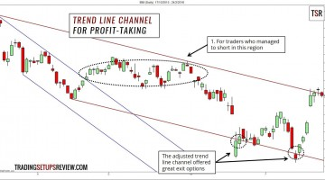

Figure 3: This is an example of the use of technical indicators in trade strategies. This is the Relative Strength Indicator (RSI) for day trading. This strategy uses one of the most well known indicators developed by J. Welles wilder.

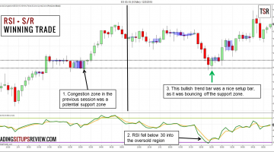

Figure 4: This is another famous use of technical indicators in trading strategy. This is the Swing Trading With Stochastic Oscillator and Candle Stick Patterns. The Stochastic Oscillator is a technical overlay that helps predict future trend lines, where the candle stick patterns help dramatically with understanding where the entry and exit points are in reference to the oscillators overlay data.

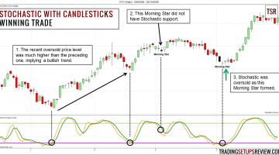

Figure 5: One of my favorites, Swing Trading With Multiple Time-Frames. This strategy is one of the more reliable ones out there since it is capable of analyzing and confirming your results by taking in multiple time frames rather than just one or two to compare.

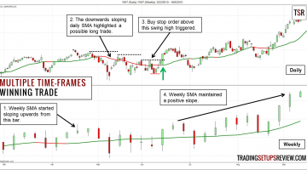

REFERENCES:

Han, Yufeng and Zhou, Guofu and Zhu, Yingzi, A Trend Factor: Any Economic Gains from Using Information over Investment Horizons? (June 2016). Available at SSRN: <https://ssrn.com/abstract=2182667> or <http://dx.doi.org/10.2139/ssrn.2182667>

Fang, Jiali and Qin, Yafeng and Jacobsen, Ben, Technical Market Indicators: An Overview (June 12, 2014). Available at SSRN: <https://ssrn.com/abstract=2449344> or <http://dx.doi.org/10.2139/ssrn.2449344>

Folger, Jean. "Using Technical Indicators To Develop Trading Strategies." Investopedia. N.p., 25 Mar. 2015. Web. 29 Jan. 2017.

Cziko, Gary A. "Unpredictability and indeterminism in human behavior: Arguments and implications for educational research." *Educational researcher* 18.3 (1989): 17-25.

Blume, Lawrence, David Easley, and Maureen O'hara. "Market statistics and technical analysis: The role of volume." *The Journal of Finance* 49.1 (1994): 153-181.

Woods, Galen. "Trading Setups Archives." Trading Setups Review. N.p., 03 Jan. 2017. Web. 29 Jan. 2017.

Fundora, Joey. "Multiple Time Frames Can Multiply Returns." Investopedia. N.p., 09 Aug. 2016. Web. 29 Jan. 2017.

Hwang, Soosung, and Mark Salmon. "Market stress and herding." *Journal of Empirical Finance* 11.4 (2004): 585-616.